JobBuddy: A Multi-Agent System for Automated Job Application Tracking

Introduction
This project was created as part of the Agents Intensive – Capstone Project by Google and Kaggle, where the goal is to apply the concepts of multi-agent systems to solve a real-world problem. As active job seekers ourselves, we wanted to choose a challenge that felt personal, relatable, and genuinely useful. During the course week, we learned how powerful agents can be when they collaborate, manage context, and automate workflows. That inspired us to build something that could make everyday life easier not just for us, but for anyone trying to stay afloat during a long and overwhelming job search. This is how JobBuddy was born: an agentic system designed to turn inbox chaos into clarity and transform the job-tracking process into something organized, reliable, and stress-free.
Core Concept
Both my teammate and I are actively job hunting, and we kept running into the same frustrating situation: we would apply to dozens of roles, but hear back from only a handful. Because of this low callback rate, every single response matters yet we often missed important emails simply because they were buried under newsletters, alerts, or other irrelevant messages.
We realised this isn’t just our problem. Many job seekers apply to a high volume of roles, receive scattered communication, and then lose track of where they stand. One missed email could mean a missed interview opportunity. The real issue isn’t just applying rather it’s tracking everything that happens afterward.
The central idea of JobBuddy is simple but powerful:
Let AI agents handle the inbox clutter and job-tracking chaos, so humans can focus on preparing for opportunities instead of searching for them.
The system uses multiple AI agents, each with a clear purpose:
- One agent reads Gmail and understands which emails are genuine application updates.
- Another agent keeps a clean, structured tracker of all applications.
- A final agent summarises the user’s weekly job-search progress.
The use of agents is meaningful and central — the project only works because each agent has independent reasoning, yet cooperates within a structured workflow.

Value
JobBuddy brings value in three major ways:
1. Emotional Relief
Job searching is already stressful. Constantly checking your inbox, worrying about missing a recruiter’s message, or trying to remember which company you applied to adds unnecessary pressure. JobBuddy removes that mental load.
2. Practical Organization
Instead of manually digging through emails or updating spreadsheets, the system:
- detects application confirmations
- tracks follow-ups and interview steps
- updates statuses
- highlights “stalled” applications
- maintains a clean and up-to-date tracker
The user gets clarity, not clutter.
3. Better Opportunities
By catching important emails early, JobBuddy reduces the risk of:
- missing interviews
- ignoring recruiter replies
- forgetting to follow up
- losing potential opportunities
For anyone applying to dozens of jobs at once (which is most job seekers today), this agentic system offers real, everyday value.

Problem
During our job search, we noticed a pattern: we were applying to so many roles that our inboxes became chaotic very quickly. Important emails interview invites, recruiter replies, screening messages were getting buried under job alerts, newsletters, automated “recommended jobs”, or completely irrelevant content.
There were times when we found out days later that we had actually received an interview email but didn’t notice it in time. This wasn’t because we weren’t checking our inbox. It was because the important things were surrounded by too much noise.
We tried spreadsheets, notes, reminders but none of them stayed fully updated.
The real challenge wasn’t applying to jobs; it was managing the flood of communication afterward.
We knew many others were facing the same issue.
Solution
We built JobBuddy — a multi-agent system that acts like a personal job-search assistant.
JobBuddy connects to the user’s Gmail and automatically:
- identifies only the emails related to real job applications
- ignores generic job alerts
- extracts important information (company, role, status, date)
- syncs everything into a Google Sheet tracker
- highlights updates or changes in application status
- generates a clean weekly summary of the user’s job search
Instead of scrolling endlessly through Gmail or updating spreadsheets by hand, the user now gets one organized view updated automatically.

Architecture
JobBuddy is an automated system that reads your messy Gmail inbox, finds all the emails related to your job applications, converts them into clean structured data, stores them in a Google Sheets tracker, and then gives you a weekly summary of your job-search progress. Behind the scenes, it uses a set of Gmail + Google Sheets API tools to fetch emails and update the sheet, and three specialized LLM agents InboxAgent, TrackerAgent, and InsightsAgent that work in sequence. The pipeline flows like this: InboxAgent pulls raw emails and extracts company/role/status using AI, TrackerAgent syncs those structured entries into your Google Sheet, and InsightsAgent reads the updated tracker to produce a clear, friendly weekly report on your applications.

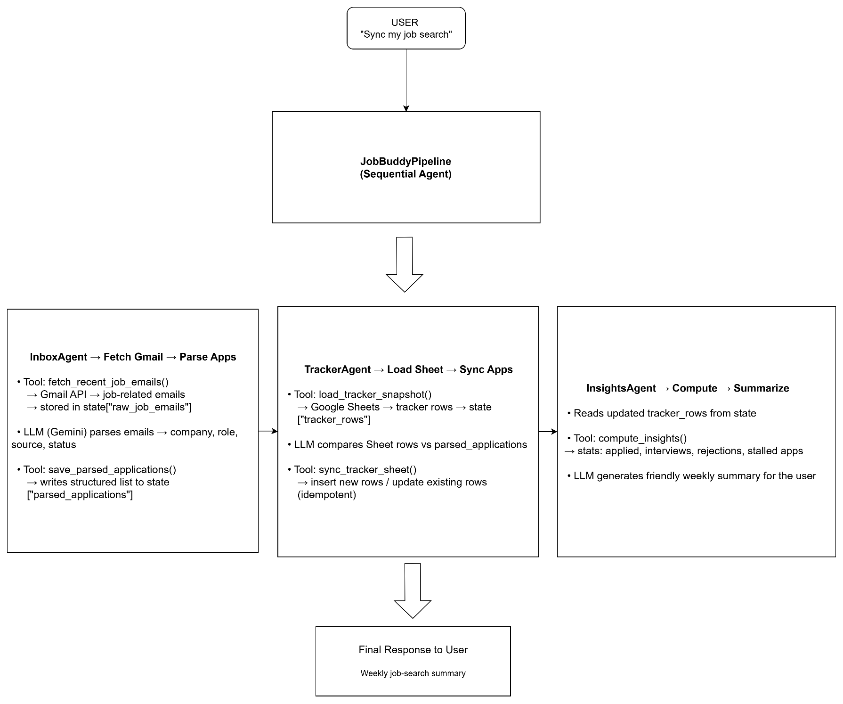
Flow explained
1. InboxAgent → Fetch Gmail → Parse Applications
When the user triggers the pipeline, the whole process begins with the InboxAgent. Its first job is to call the tool fetch_recent_job_emails(max_results), which uses the Gmail API to pull in only job-related emails things like application confirmations, recruiter updates, or interview invites. The raw results are stored in tool_context.state["raw_job_emails"] for the agent to analyze. For this project we have considered for the last one week mails. This could be edited to increase the timeline.
After receiving these emails, InboxAgent uses Gemini to read through the subjects and snippets and extract meaningful application details such as the company, role, source, and status. Once this structured list is ready, the agent calls the second tool, save_parsed_applications(parsed_applications), which writes this cleaned dataset into session state. At this point, the messy Gmail inbox has been transformed into a clear list of job applications.
2. TrackerAgent → Load Sheet → Sync Applications
Next, control moves to the TrackerAgent, whose job is to maintain the Google Sheets job-tracker. It starts by calling load_tracker_snapshot(), which loads all previous applications from the Sheet into the session state. With both the Sheet data and the newly parsed Gmail data side-by-side, TrackerAgent compares them and decides whether an application should be added as a new row or treated as an update to an existing one.
Once this plan is ready, it calls sync_tracker_sheet(), a tool that updates the Sheet in a clean, idempotent way inserting new rows or updating old ones without duplication. After this step, your Google Sheet is fully aligned with the latest activity in your Gmail.
3. InsightsAgent → Compute Stats → Generate Summary
Finally, the InsightsAgent steps in to interpret the data. It reads the now-updated tracker and calls the tool compute_insights(), which calculates your job-search statistics how many applications you sent this week, which ones moved to interviews, which got rejected, and which look stalled or need follow-ups. Using this tool output, InsightsAgent writes a simple, friendly summary that tells you exactly how your job-search week went, without needing to dig through emails or spreadsheets.
4. JobBuddyPipeline → Orchestrates the Full Flow
All three agents run in a fixed sequence inside the SequentialAgent pipeline: InboxAgent → TrackerAgent → InsightsAgent. The Runner and InMemorySessionService keep the session state persistent so each agent can build on the work of the previous one. With this setup, a single message like “Sync my job search and tell me how my week went” automatically triggers the entire pipeline fetching emails, extracting applications, updating the Sheet, and producing a weekly summary.

Results
JobBuddy successfully completed the full end-to-end flow — from reading Gmail, to updating the Google Sheet, to generating a weekly summary. The results were exactly what we hoped for: clear organization, accurate tracking, and insights that make the job search easier to manage. This populated the Applications sheet with clean, structured data extracted directly from Gmail.
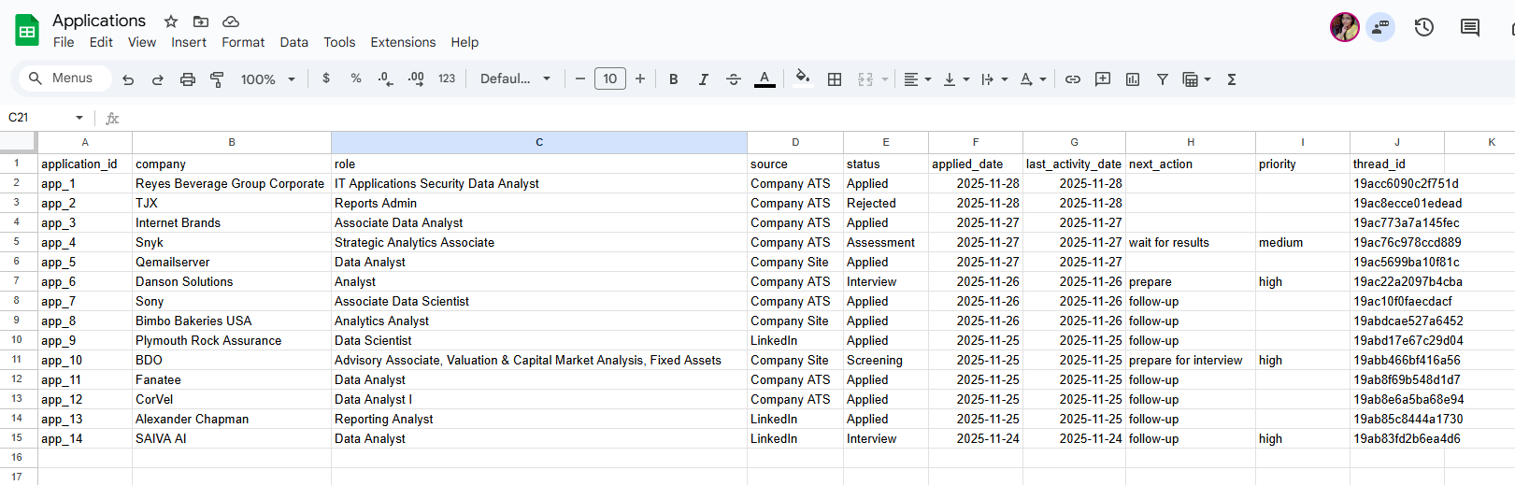

Weekly Summary Automatically Generated
After syncing the sheet, JobBuddy produced a clean weekly report that captured the user’s job search activity in plain language. It gives an overall summary of the total applications done this week.

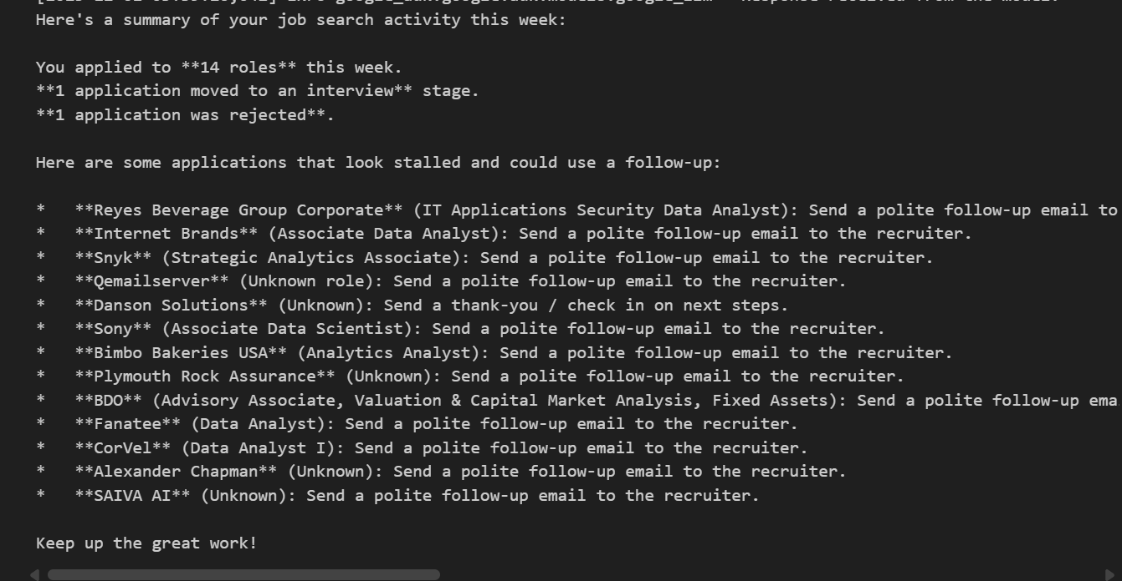

Learnings Applied from the 5-Day AI Agents Intensive
Concepts We Applied
- Multi-agent system
- LLM-powered agents
- Sequential agent orchestration
- Custom tools (Gmail fetch, Sheets sync, insights computation)
- Sessions & state management using InMemorySessionService
- Observability through structured logging

Throughout this project, we intentionally applied several core ideas from the 5-Day AI Agents Intensive. One of the most influential concepts was building a multi-agent system, where different agents specialize instead of relying on one model to do everything. We designed three focused LLM-powered agents and connected them using sequential orchestration, allowing each stage—email reading, sheet syncing, and insights generation—to flow cleanly into the next.
The course also emphasized extending agents beyond language alone, so we incorporated custom tools to handle real-world actions such as fetching Gmail messages, reading tracker data from Sheets, and updating application rows. These tools allowed the agents to interact with external systems in a controlled, reliable way.
Another concept we adopted was session-based state management. Using InMemorySessionService, all agents share a consistent context: one agent writes to state, the next reads from it, and the final one builds on the combined results. This mirrors the structured memory-handling patterns demonstrated during the intensive.
Finally, we implemented observability by adding clear, intentional logging throughout the tool layer. This gives us a transparent trace of decisions, tool calls, and updates—making debugging easier and ensuring the overall pipeline behaves predictably.
Together, these elements reflect the practical lessons we learned from the course and show how agentic design principles can be combined to build a reliable end-to-end workflow.

Conclusion
Building JobBuddy allowed us to turn everything we learned during the intensive course into something real and genuinely helpful. Instead of creating a theoretical demo, we built a system that solves a problem we face every day keeping track of job applications without the stress of checking emails constantly. By combining agents, tools, and shared context, we ended up with a workflow that feels smooth, organized, and surprisingly reliable. More than anything, this project showed us how powerful agentic systems can be when designed with a clear purpose: taking small but overwhelming tasks off people’s plates so they can focus on what actually matters.

